**V—2.1(Docker Run in Detail):**

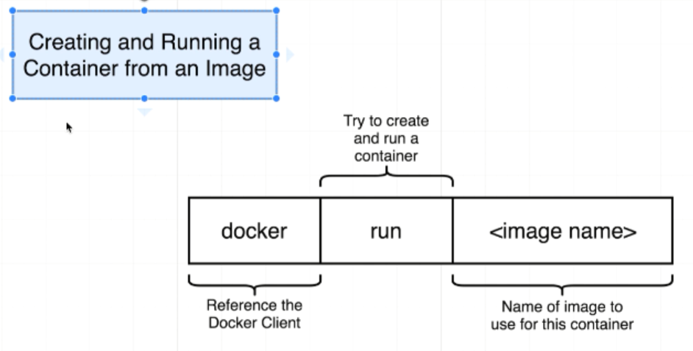

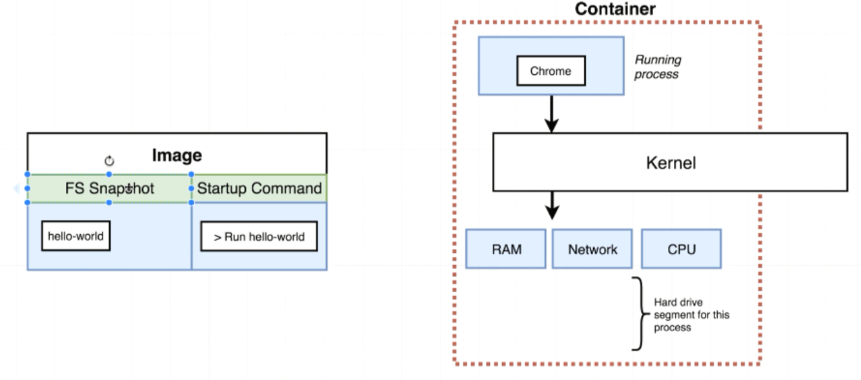

Somewhere on our hard disk is an image that has that file system snapshot with one single program inside it. When we execute that ***docker run hello-world***. We took that snapshot of the hard drive. We stuck it into the little container or kind of grouping of resources and then we executed the command >Run hello-world and then the running process up there is hello-world

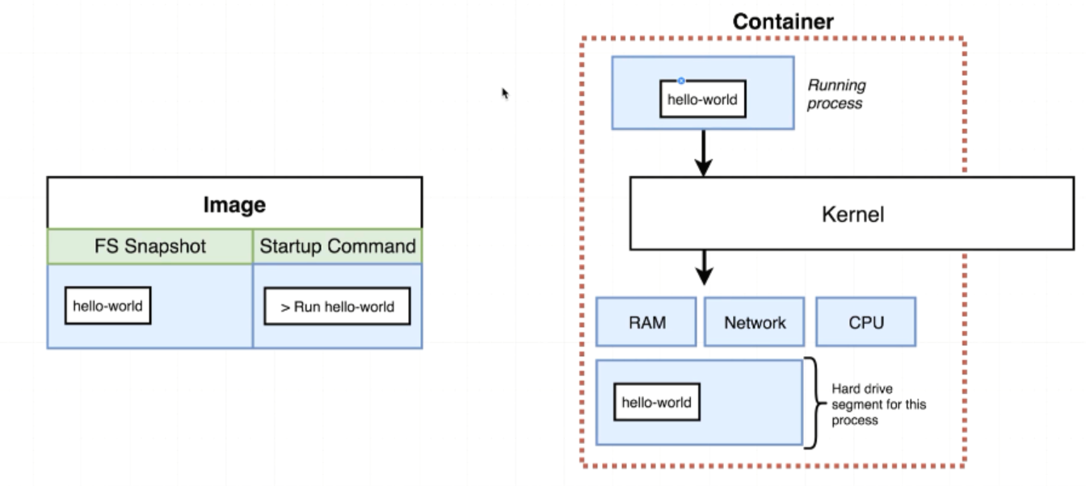

Whenever we execute docker run hello-world, we not only get that filesystem snapshot but we also get this default command that is supposed to be executed after the container is created

**V—2.15:Overriding Default Command(*docker run <image-name>*)*:***

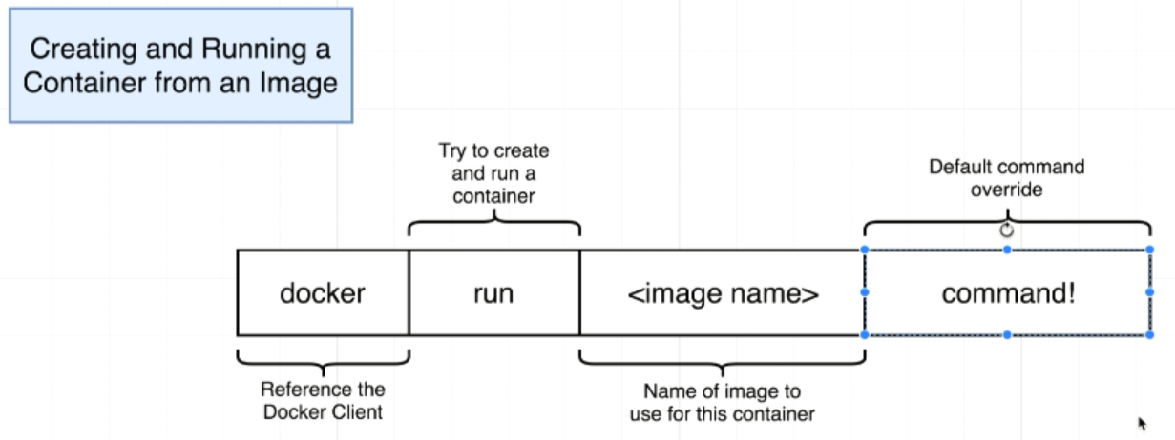

So whatever default command is included inside the image is not going to be executed. Here we are overriding the default command.

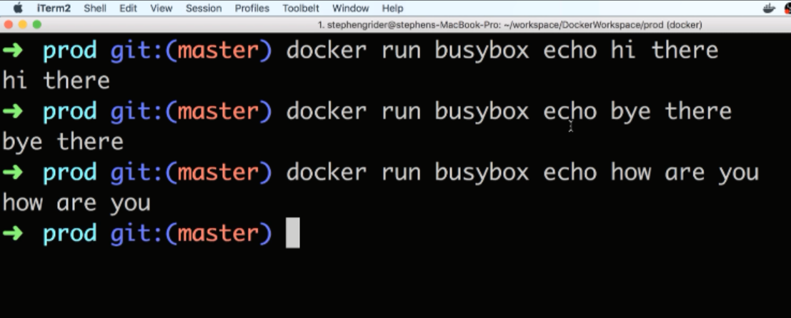

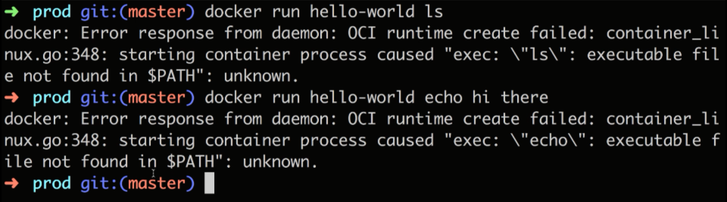

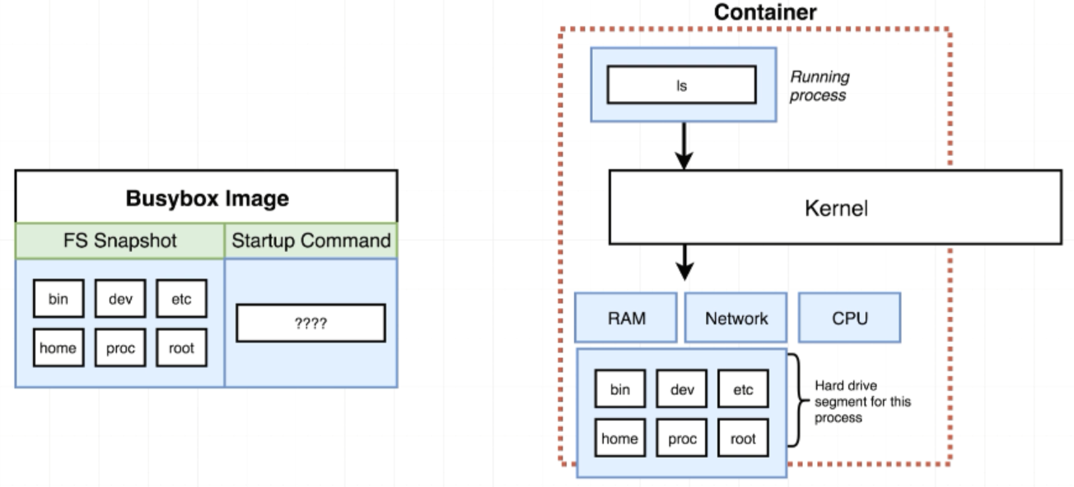

ls and echo will not work with hello-world image because ls and echo are two programs that exists inside the busybox File System image. But in hello -world that exists in File System is a single program

If we try to execute a command inside the container which uses a program that does not contained with in the File System we are going to see the error.

**V—2.16:Listing Running Container:**

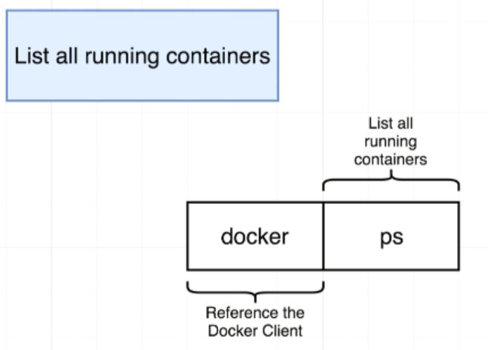

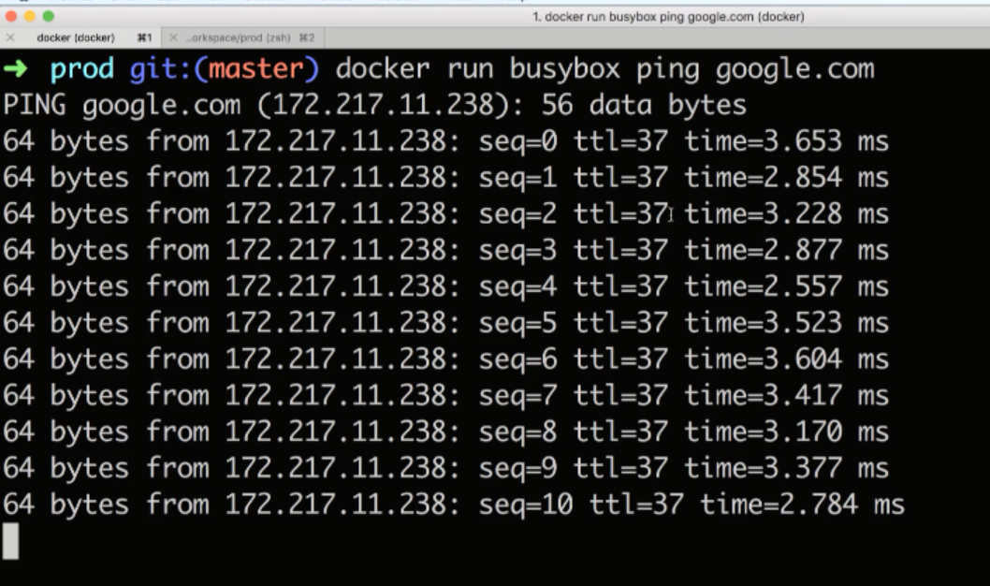

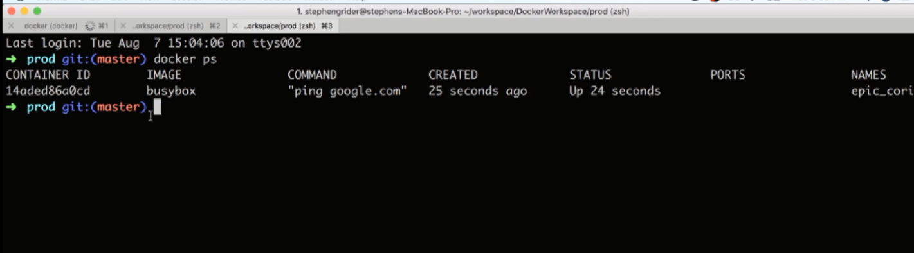

**To List all the container we have created ever been:**

***docker ps --all***

***Ports:***Any ports that have been opened up

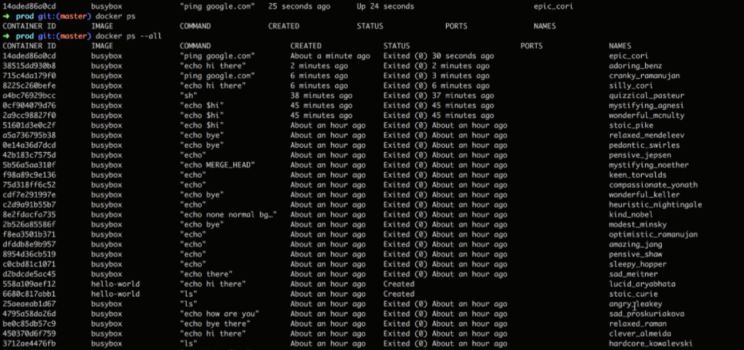

*One of the most common usage of docker ps is not only to see what’s running and but also to get the ID of the running container*

*We need to issue specific commands on a container for that we need ID of the container*

**V—2.17(Container Life Cycle):**

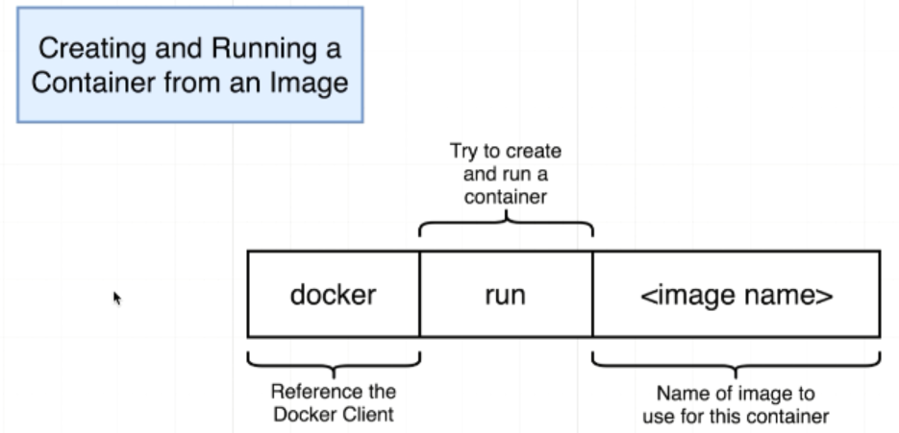

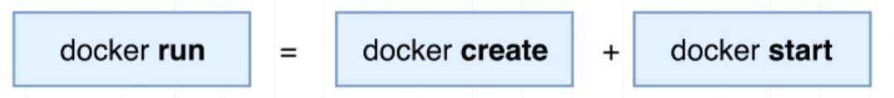

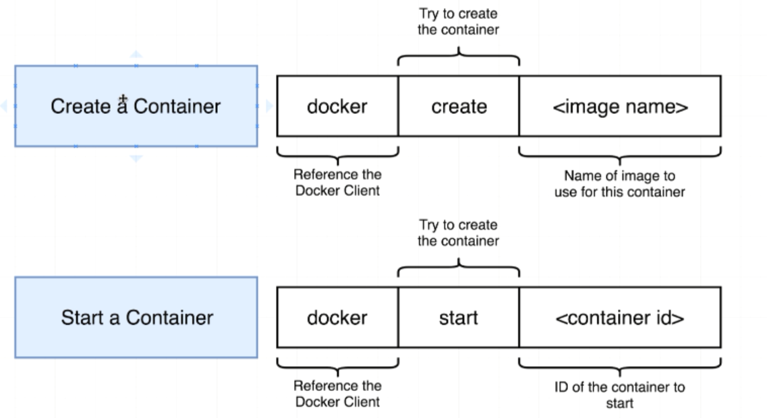

**Creating a container**

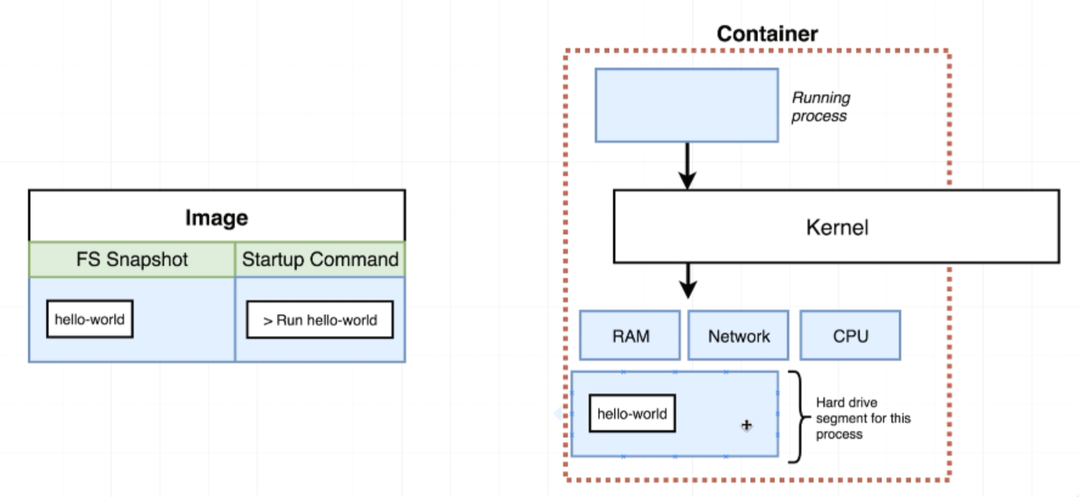

**Starting a container**

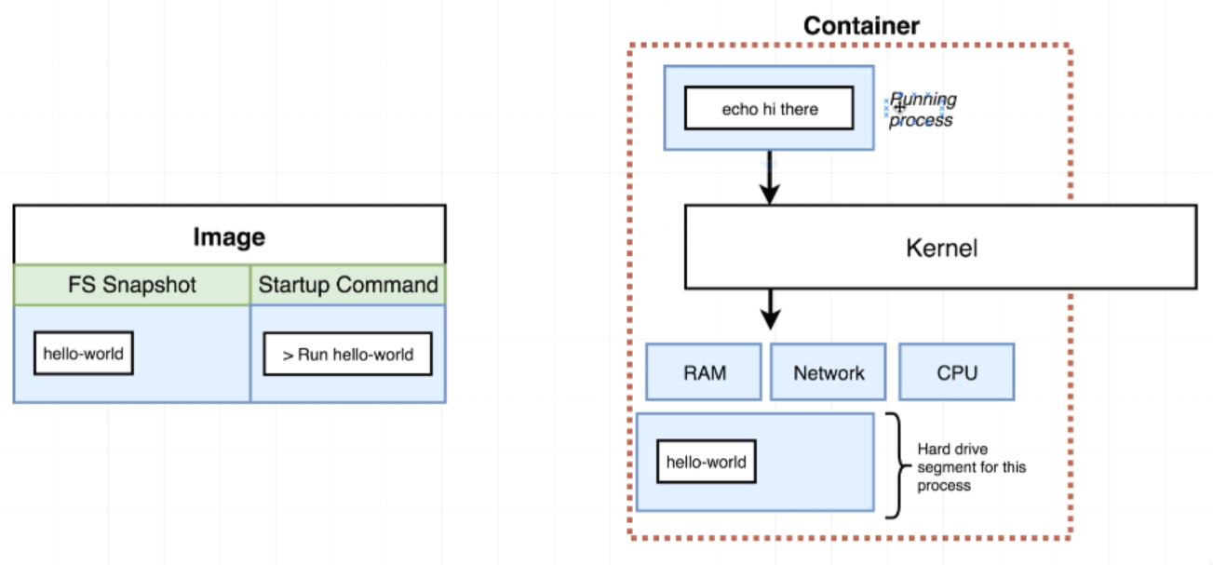

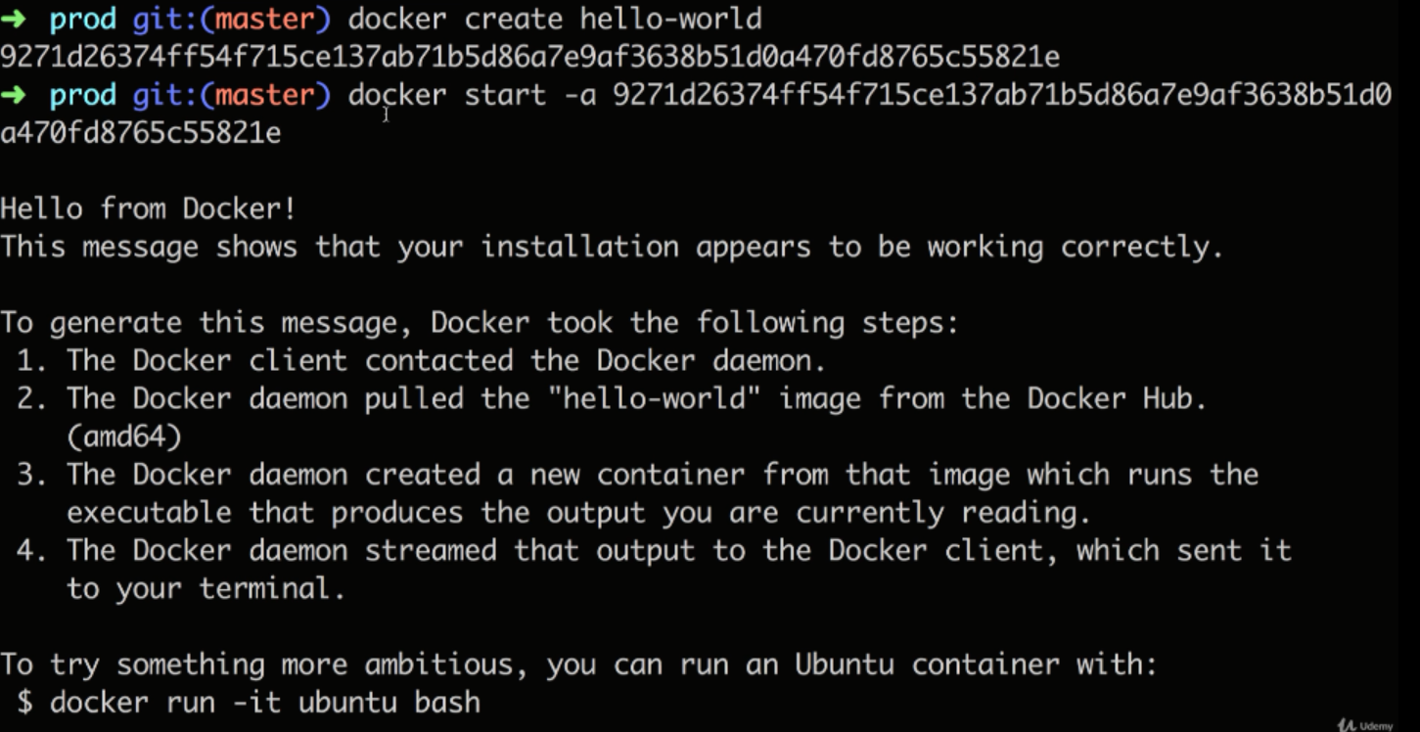

**-a : it will take the output coming from the container**

**If we start docker container without -a: It will show only docker container ID.**

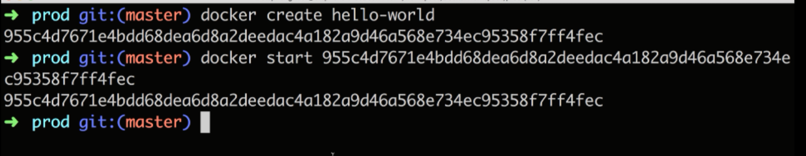

Docker run is going to show all the logs or all the information coming out of the container by default docker start is the opposite. Docker start will not show information coming out of terminal

**V—2.18(Restarting Stopped Containers):**

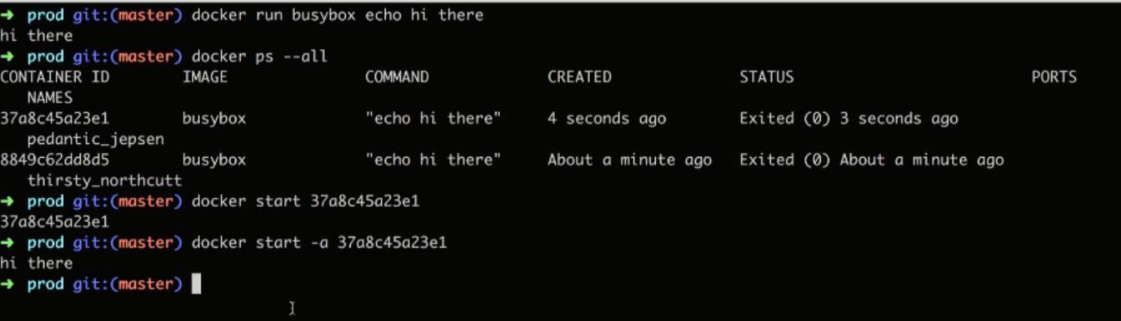

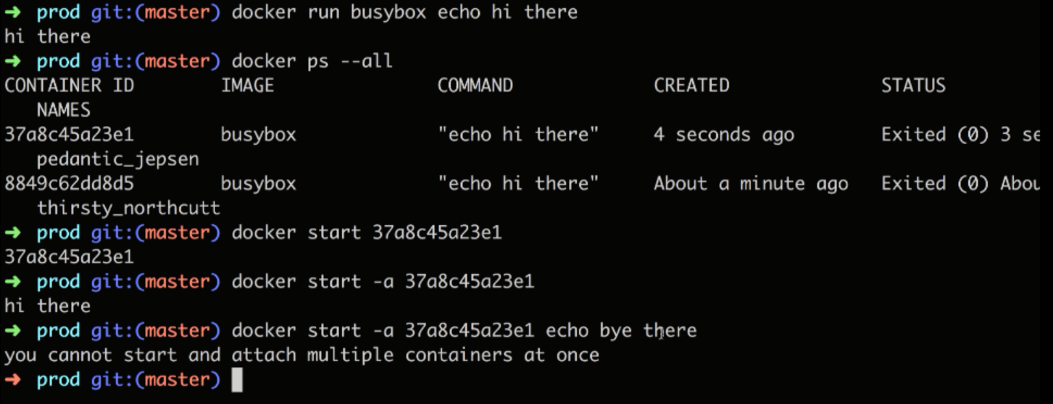

So once we have started a container and let it exit we can start it again which is going to reissue the default command that was used when the container was first created.

**V—2.19(Removing stopped containers):**

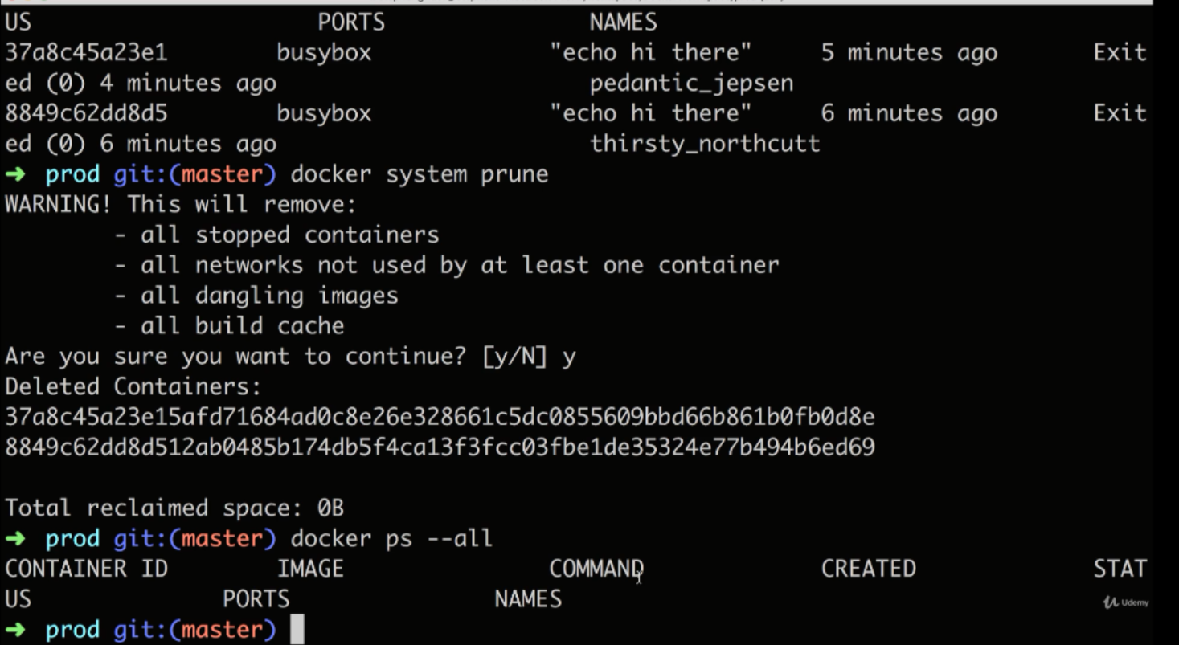

Build Cache is place where we fetch images from Docker Hub

**V—2.20(Retrieving Log Outputs):**

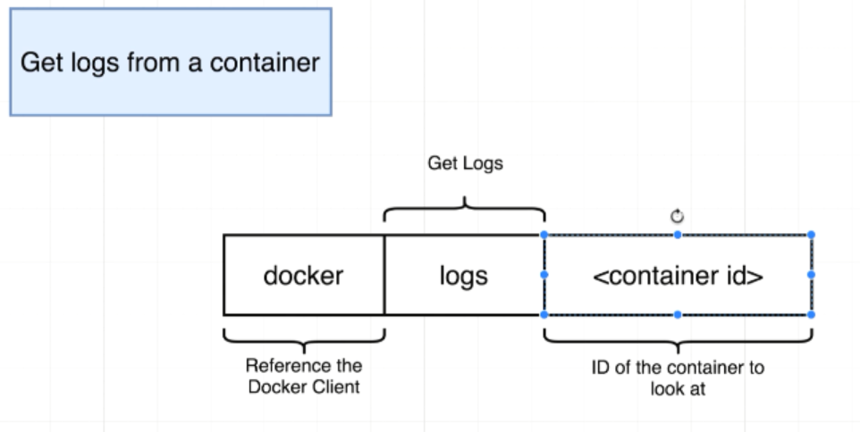

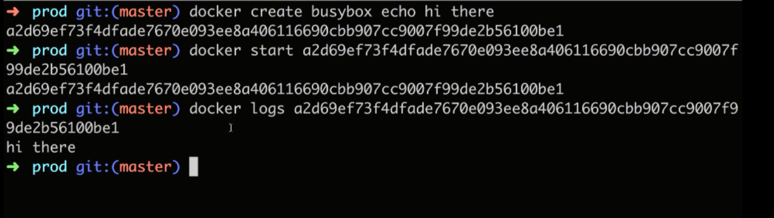

Here we are not rerunning or restarting the container, we are just getting a record of all the logs that have been emitted from the container

Used to inspect a contiainer to see what’s going inside or debug or setup new containers

**V—2.21(Stopping the Containers):**

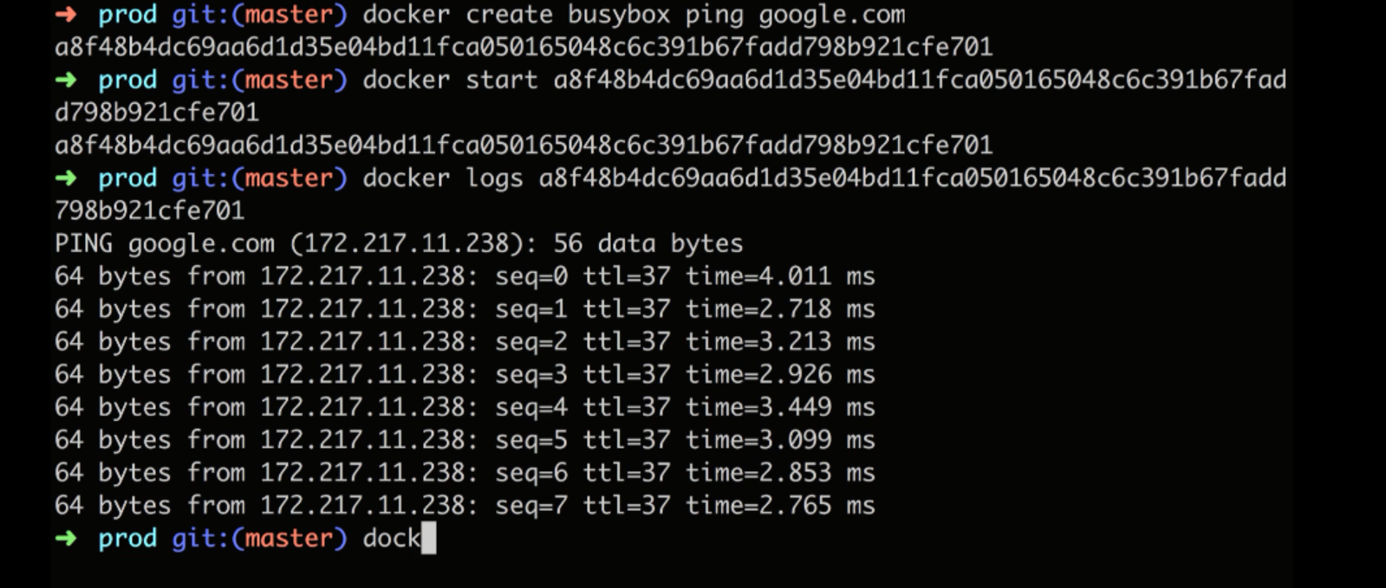

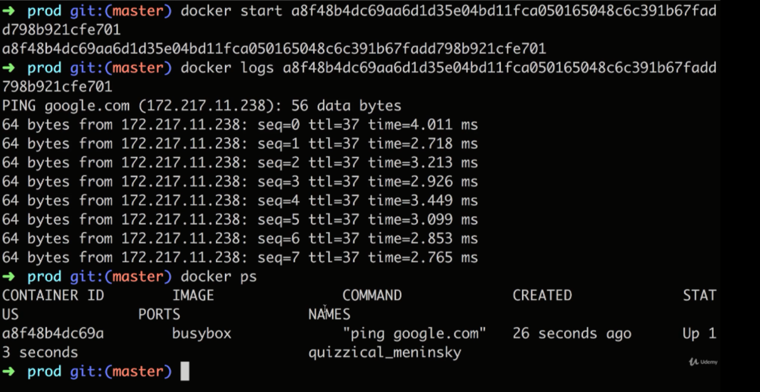

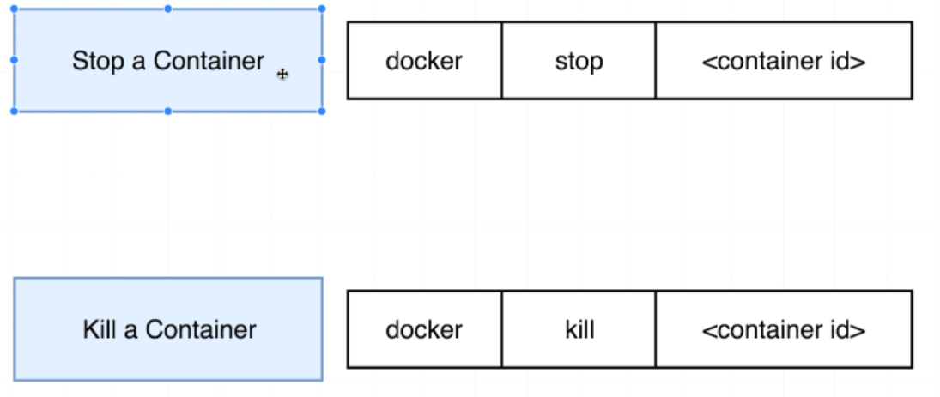

**SIGTERM --- Single Termination**

**SIGKILL --- Kill Single**

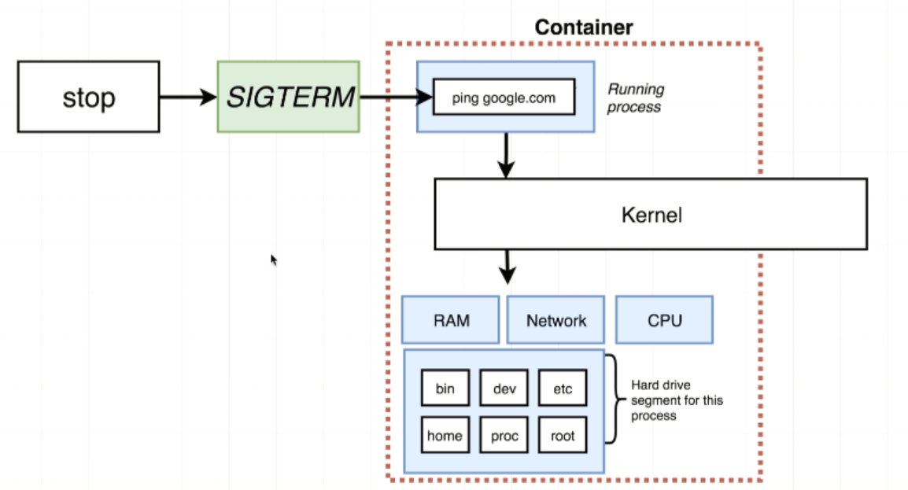

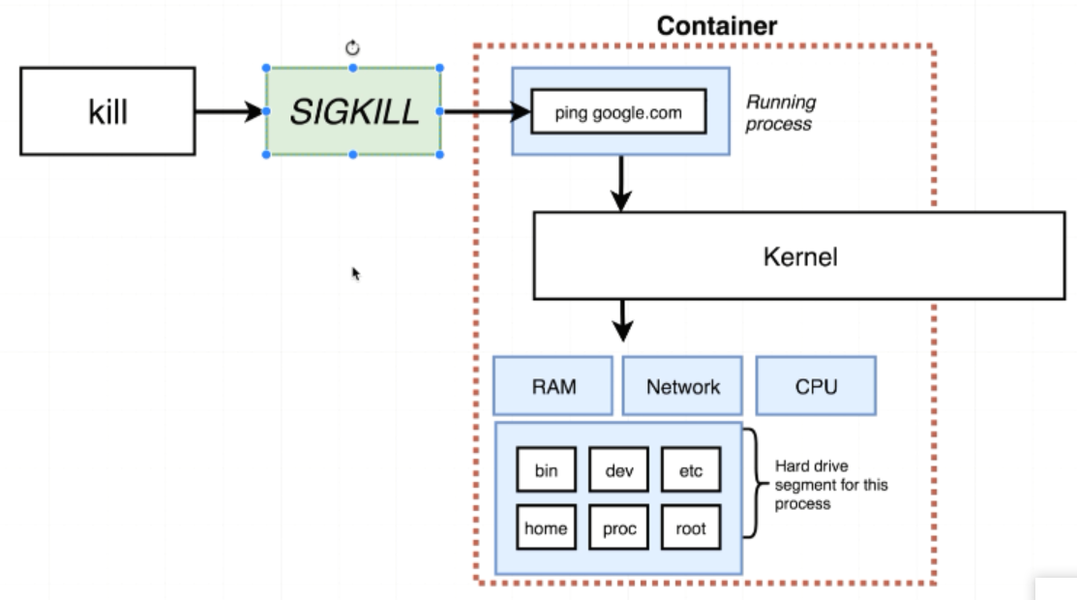

docker stop <container_id>. This stop will give the process sometime to shut itself down and do cleanup may be save some file or emit some message.

docker kill <container-id>. This kill will tell to shutdown right now without any additional work

In Some cases, docker stop <container_id> takes 10 seconds to stop the container. If it takes 10 seconds then automatically docker kill <container_id> will be executed.

**V—2.22(Multiple Command Containers):**

Reddis is a in-memory data store that is used with web-applications

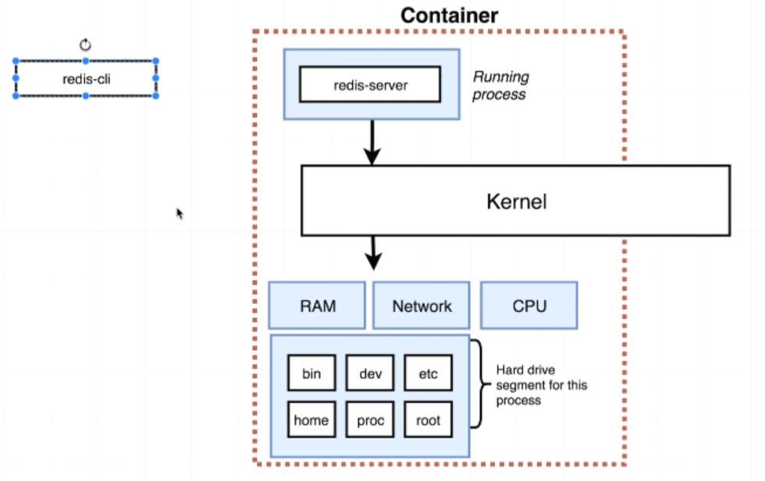

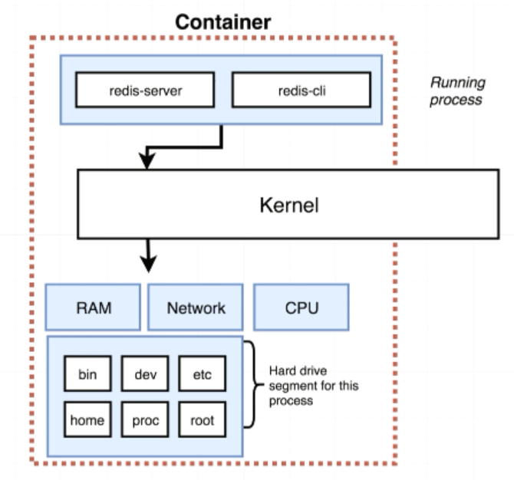

**We started a new container that is running reddis server, reddis is running only inside the container. If we try to run reddis-cli outside the container. We don’t have access what is running inside the container. To execute a reddis-cli, we need to get into the container and run a second command(Second program).**

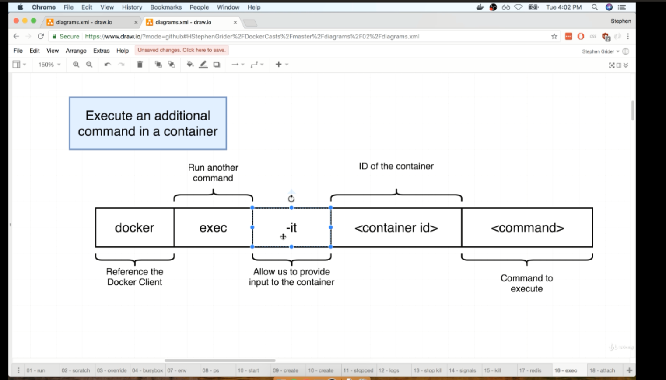

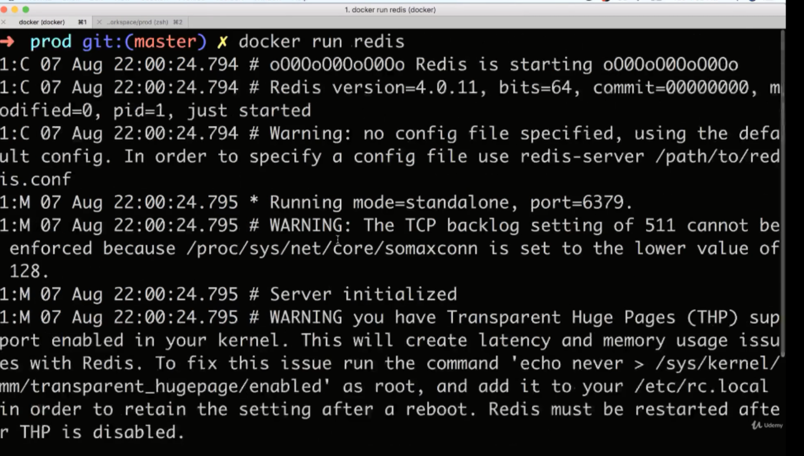

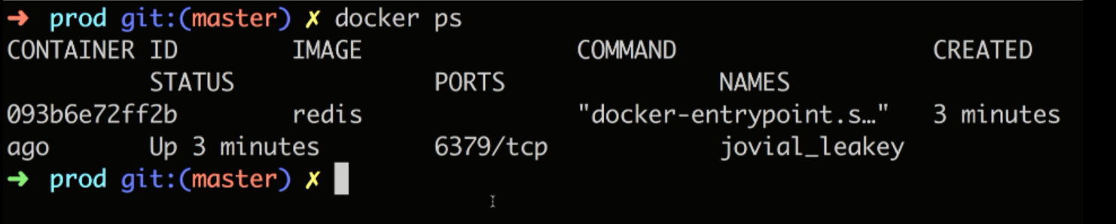

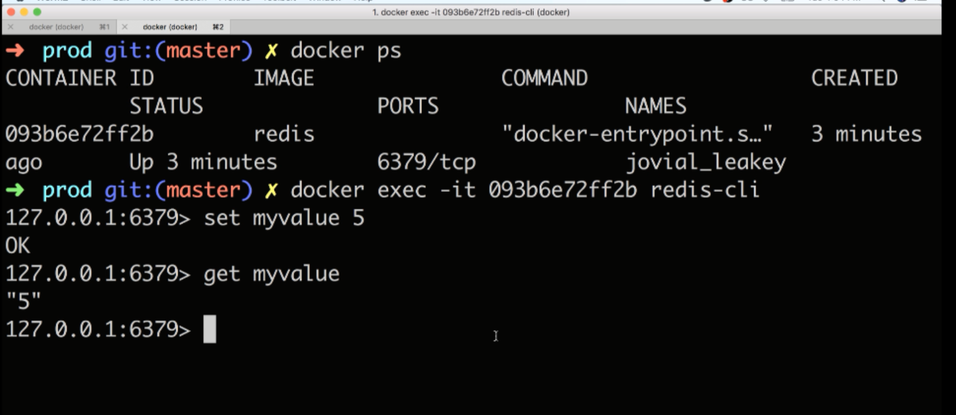

**V—2.24(The Purpose of IT Flag):**

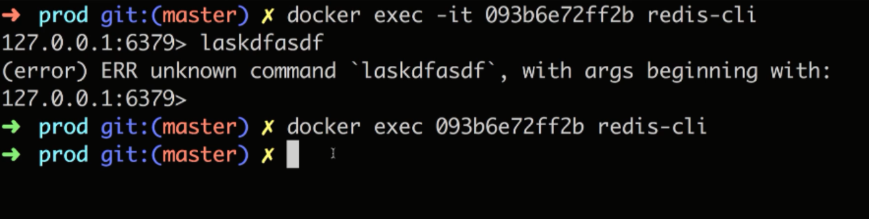when we are running docker on our machine, every container you are running is running inside of a virtual machine running Linux. So these process are being executed inside of a Linux world even you are on mac or windows**.**

**Every process created in the Linux Environment has three communication channels attached to it.**

**These channels are used to communicate information either into the process or out of the process**

**Stdin(standard in):is used to communicate information inside the process**

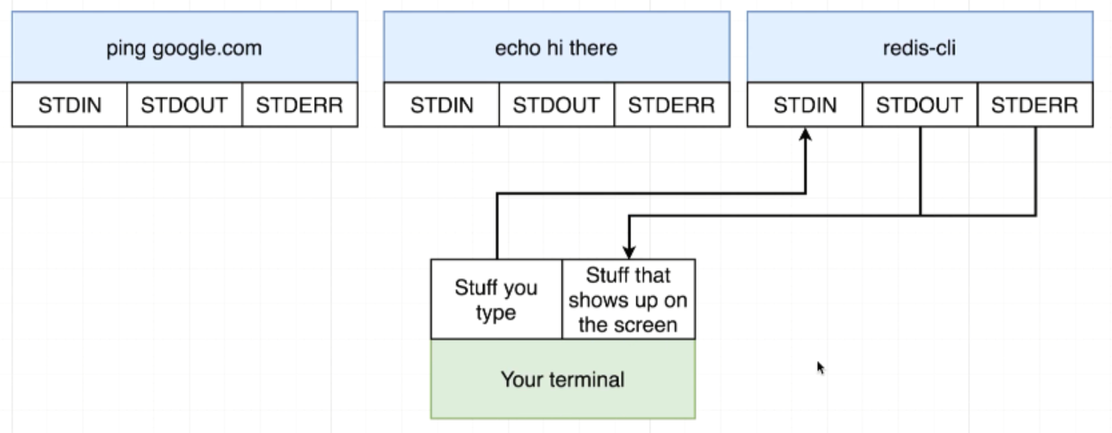

**In -it :**

**-i means when we execute this new command inside the container we want to attach our terminal to the standard in channel of that new running process.**

**So by adding -i flag we are making sure that any stuff that we give gets redirected to stdin of reddis-cli**

**-t means -t flag is to make sure that all the text that you are entering in and that coming out shows up in a nicely formatted manner on your screen**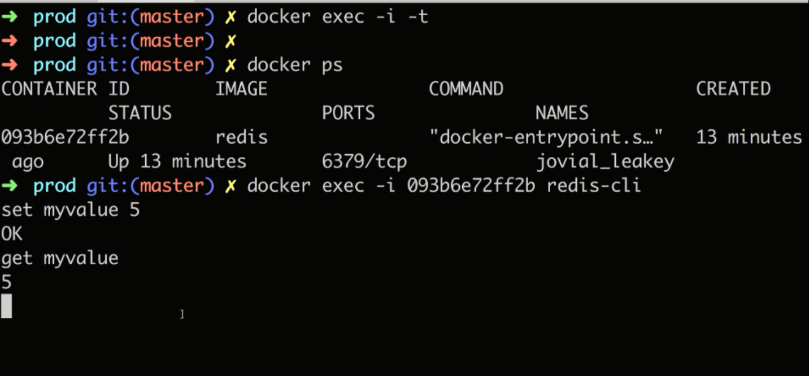

**V—2.25(Getting a Command Prompt in a Container):**

**If we run cmd in a container, we no need to run docker exec every time**

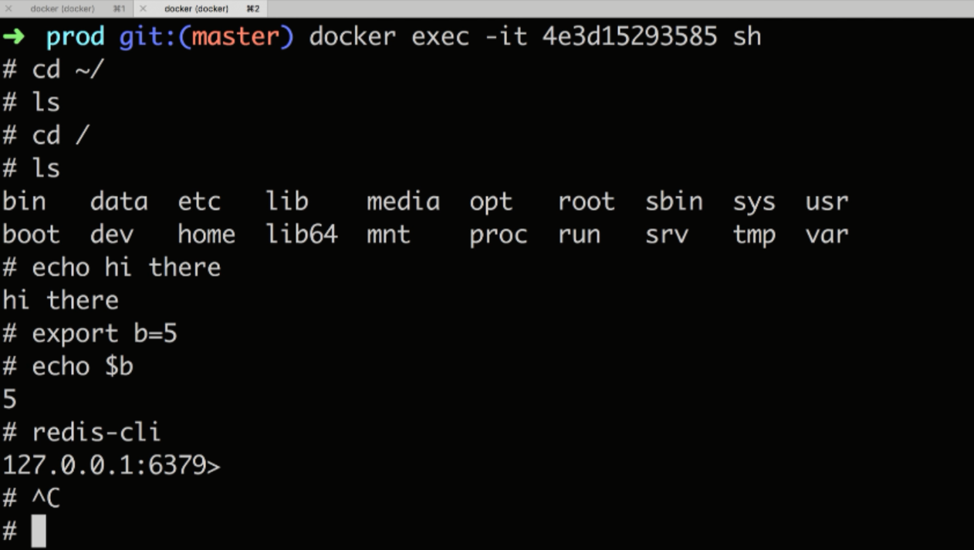

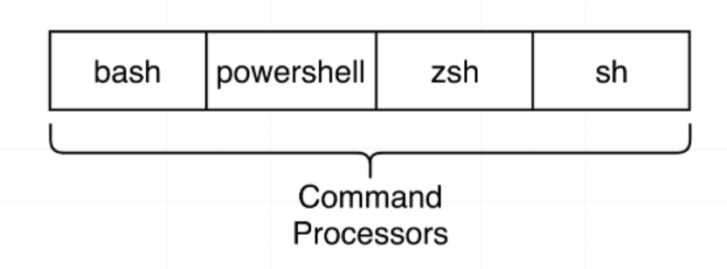

**sh is a program that is executed inside the container. Sh is a command processor or shell that allows us to type commands in and have them executed inside the container.**

**V—2.26(Starting up a shell):**

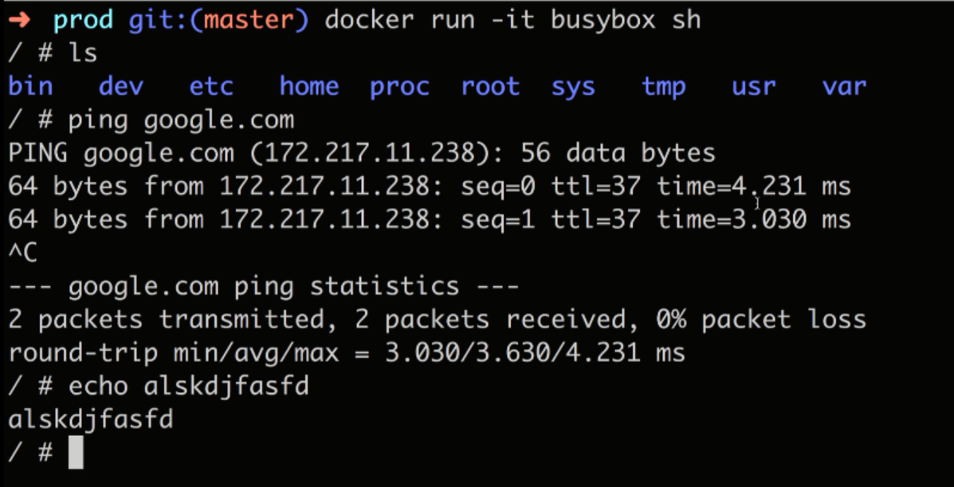

**V—2.27(Container Isolation):**

**Two same running containers have separate File System.**

**Container-1:**

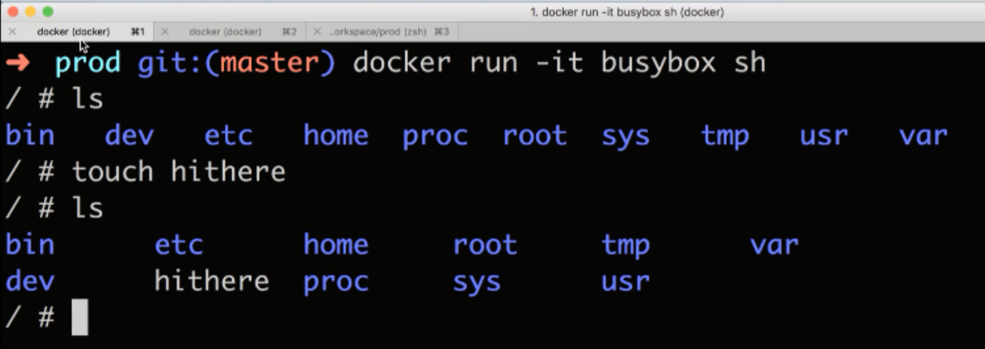

**Container-2:**

